Custom Models: https://getargeting-2026.vercel.app/custom-mouse-models

- Can you please change every mention of capitalized “Ingenious Targeting Laboratory" to lower case “ingenious targeting laboratory” across our site? Also, is the second paragraph in the below supposed to be a smaller text size than the first?
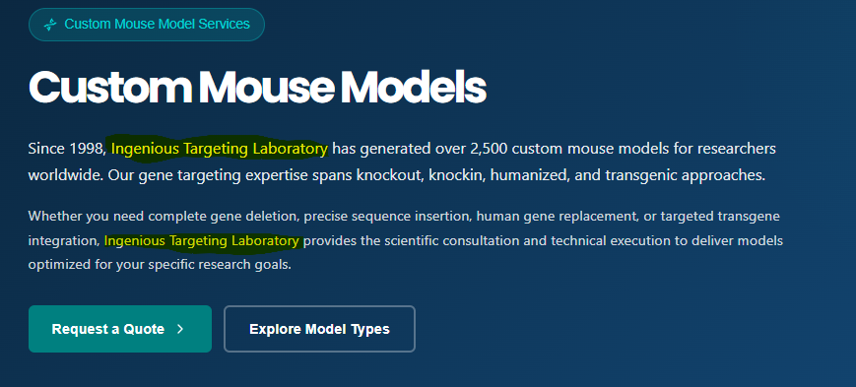

- We may need to change this to 100% germline transmission guarantee (not success guarantee):
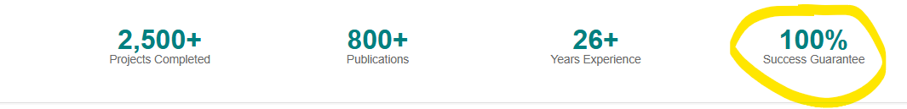

- Can you change the word “molecules” to the word “proteins”:
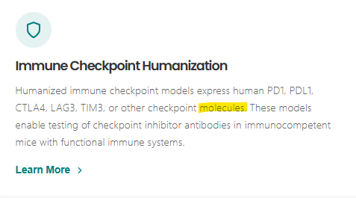

- Can you put parentheses around the word “BAC” so it looks like (BAC). Also, this clicks back through to the Custom Mouse Model page. I’m not sure if it’s supposed to click through to a BAC page?:
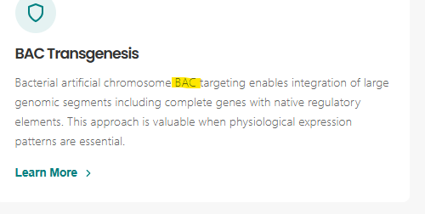

- I’m not sure how the AI generated the below info. If it’s not true to our publications, I’d rather use our real articles rather than fake generated ones. Plus citing something from 2024 and 2023 is considered old now in terms of science. Or maybe we can this because I understand it’s a concept, and just change the dates:
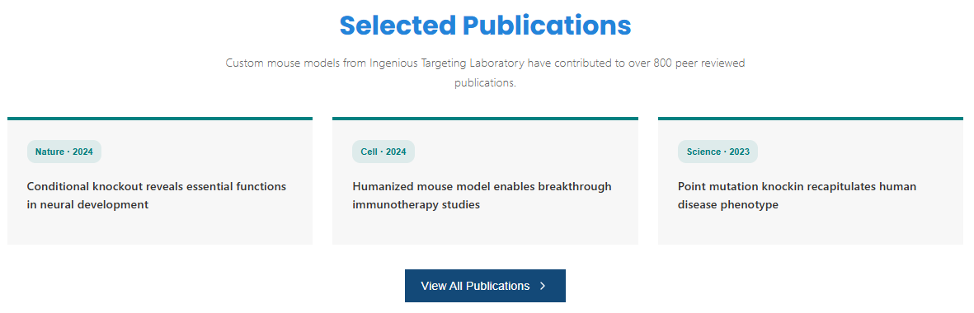

- I think we may need something catchier to get people to sign up for lab signals. Most scientists won’t care about mouse model design, targeting strategies, or best practices. What do we say in our ads for Lab Signals? Maybe incorporate that language:


- We may want to ask Paul if this is OK to use (even across the site) for timeline, or if we should just remove it completely:
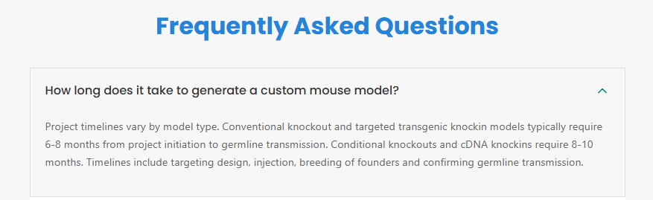

- The transgenic mouse service links right back to the Custom Models page. Should this go to a transgenic page? The timeline link goes to a 404 error page:
